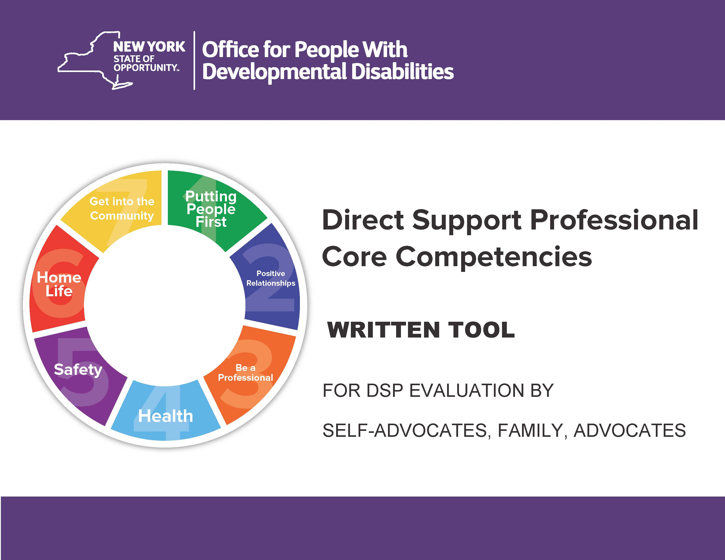
HOW TO USE THIS FORM
This is a Direct Support Professional evaluation form. It is designed so that self-advocates, family members or advocates can give feedback about the DSP who is providing services.
DSP is a term that includes many different titles and functions, each helping with activities such as getting out of bed, getting dressed, going to the bathroom, finding a job, getting to work, working effectively at a job, participating in recreational, educational, cultural, spiritual and civic functions, refining socialization skills, exercising choice and self-determination, enjoying relationships with friends and family, implementing daily practices that promote positive behavioral and physical health, remaining safe from harm, refraining from harming others, maintaining a comfortable home, communicating and expressing oneself effectively, moving around and using transportation purposefully, learning something new and practical, retaining important skills, engaging in and contributing to the community.
A person who performs one of these or similar functions for a salary, stipend, or payment for services rendered is considered a DSP.
All DSPs in New York State have to be evaluated each year on their work performance based on the DSP Core Competencies.
If you are a family member or advocate, please ask the person who receives the services for their input on all of the seven Goals. Their input is important. When the word “you” is used, it addresses the person served. It is understood that the person served may require assistance with the statements and questions.
The seven Goal areas are below. Each one has examples of how the DSP may be providing supports. Under each goal, check whether the DSP “Exceeds,” “Meets,” or “Does not Meet” the competency goals. “Making Progress” may be selected, ONLY if it is an initial evaluation of someone who is in their first three months of employment as a DSP. In Goals 6 and 7, the goal area and questions may not apply. In those cases, you can check “Not Applicable.”
There is also an area for comments under each goal. You do not have to fill in comments, but it is very helpful for the DSP if you can say what they are doing well and what could improve.
The DSP’s supervisor, representing the agency which is the employer of record, will use the information you provide to inform the DSP on how they are performing their job. If you have questions, please contact your DSP’s agency for assistance.

Direct Support Professional Name _____________________________________________________________________
Agency Name __________________________________________________ Check, if Self-Directed Services _______
Name of Person Completing This Evaluation ______________________________________

Goal #1 – Putting People First - The DSP is expected to get to know you and support what you want and need.

Questions For You To Consider:
- How does the DSP help you to make informed decisions (For example: What to eat, what to wear, where to go/do and with whom)?
- How well does the DSP know you? (For example: Do they know what to do when you are upset? Do they know what makes you happy?)
- Does the DSP help you learn new things?
- If you use any equipment, does the DSP know how to manage that equipment so you are comfortable?
- If you receive help with eating, how well does your DSP assist you?

Exceeds Meets Making Progress Does not Meet
(For initial evaluation only)

______ ______ ______ ______

Comments: (Optional)

Goal #2 – Building and Maintaining Positive Relationships - The DSP should help you to see your own personal strengths and their value.

Questions For You To Consider:
- How has the DSP helped you to get along with your neighbors and other people in your life?
- How has the DSP helped you to learn about people in the community or activities you could do? (For example: Religious groups, singing groups, volunteering someplace)
- How does the DSP help you to have friends, or a boyfriend or girlfriend?

Exceeds Meets Making Progress Does not Meet
(For initial evaluation only)

______ ______ ______ ______

Comments: (Optional)

Goal #3 – Demonstrates Professionalism - The DSP is expected to be professional and ethical and trustworthy.

Questions For You To Consider:
- Does the DSP regularly meet time and attendance expectations?
- Do you trust the DSP?
- Does the DSP speak with you respectfully?
- Does the DSP give you full attention, asking your permission first if they have to use their phone for a personal emergency or leave to use the bathroom?
- Does the DSP listen to you and answer you? Does the DSP help you to do the things you want to do based upon your plan?
- Is the DSP respectful of your relationship with your family and friends?
- Does the DSP respect your privacy? Are you comfortable with how they help you with personal hygiene tasks? Are they gentle and respectful?
- Is the DSP respectful of cultural and/or religious practices in your life and your family’s life?
- Do you feel comfortable sharing information with your DSP that you may not want to share with others?

Exceeds Meets Making Progress Does not Meet
(For initial evaluation only)

______ ______ ______ ______

Comments: (Optional)

Goal #4 – Supporting Good Health - The DSP should support healthy living practices, such as diet and exercise, stress reduction and emotional support, as well as doctor and dentist visits.

Questions For You To Consider:
- Do you feel the DSP would help you if someone was hurting you in any way?
- How does the DSP help you to be healthy; for example, helping with exercise, healthy food choices, doctor and dentist appointments and reducing stress?
- Does the DSP help you learn about things that are good for your health?

Exceeds Meets Making Progress Does not Meet
(For initial evaluation only)

______ ______ ______ ______

Comments: (Optional)

Goal #5 – Supports Safety - The DSP is expected to know and safely support you if there is a crisis situation. The DSP is familiar with all safety measures and procedures to be taken in all areas and when traveling.

Questions For You To Consider:
- How does the DSP help you to be safe? For example:
- In your home: fire safety, locking doors, safety hazards such as overloading electrical outlets, cooking;
- In your community: crossing streets, meeting strangers, using transportation, using the internet, calling 911, when to see your doctor or go to the emergency room; and
- Knowing your allergy and medical conditions and the appropriate actions to take to support your safety
- Ensuring that you are not neglected or abused in any way.

Exceeds Meets Making Progress Does not Meet
(For initial evaluation only)

______ ______ ______ ______

Comments: (Optional)

Goal #6 – Having a Home - The DSP is expected to support you to have a comfortable, neat and clean place to live.

Questions For You To Consider:
- How does the DSP support you to take care of your home (For example: Teaching you how to do laundry, do chores, checking locks on doors, changing lightbulbs, knowing whom to call for repairs and other problems and changing batteries in smoke and carbon monoxide detectors.
- How does the DSP help you to learn health and safety issues in the way you keep your home (For example: Access to exits—windows and doors, expired food, proper food storage, overloading electrical outlets).
- How does the DSP help you to make the place where you live into your own home (For example: Selecting personal pictures to display or other items that you like, enjoying comfortable furniture, matching the colors of your sheets etc.)

Exceeds Meets Making Progress Does not Meet Not Applicable
(For initial evaluation only)

______ ______ ______ ______ _______

Comments: (Optional)

Goal #7 – Being Active in Community - The DSP is expected to encourage and support you to take part in activities outside of your home.

Questions For You To Consider:
- How does your DSP support you to learn about your community so you may choose what you would like to do?
- How does the DSP support you to learn about different job opportunities and volunteer work in your community?
- How does the DSP support you to get a job, volunteer position, to have friends or join clubs or other organizations?
- Does the DSP help you with handling your buying things and handling your money?

Exceeds Meets Making Progress Does not Meet Not Applicable
(For initial evaluation only)

______ ______ ______ ______ _______

Comments: (Optional)

FINAL QUESTION
Are there any other comments or suggestions you want to share about what your DSP does very well for you, and what things you wish he/she could help you with more? (Optional)

Signature of Person Completing the Form Date Completed

_____________________________________________________ __________________

Relationship of Person Completing this Form to the Person Receiving Services

_____________________________________________________

Employee Signature Date Signed

_____________________________________________________ __________________

