

The Missouri Workforce and Economic Crisis We Need to Be Talking About
Published on April 8, 2019


Wendy SullivanFollow

Chief Executive Officer
- Like18
- Comment0
- Share
- 12
For years, a crisis has been growing throughout the state that now threatens the health, safety, and independence of tens of thousands of Missouri individuals and families. Persistent, long-term underfunding of intellectual and developmental disabilities (disability) services in Missouri has pushed the community to its breaking point. The most significant result of this underfunding is the crisis-level inability of organizations, statewide, to recruit and retain Direct Support Professionals (DSPs).
More than 15,000 people in Missouri work as Direct Support Professionals. From coaching individuals with disabilities at work to supporting them to live with independence in their own home, these workers fill a vital role in our health care and social services systems.
The majority of these employees are dedicated, driven, and passionate about their role in the community. Today in Missouri, they are leaving their jobs at a rate of 60% per year.
The reality is that Direct Support Professionals cannot afford to live on the salary they make – a salary that is determined in large part by state funding levels. With an average salary of just $10.72 per hour, 25% of these employees live at or below the federal poverty level — many work multiple jobs and extreme overtime to make ends meet.
More than 52% of Direct Support Professionals rely on some type of public assistance. Because their salary is dependent on state reimbursement rates, these individuals bear the brunt of the state’s failure to adequately support these critical programs. These circumstances, combined with historically low unemployment and an abundance of higher paying jobs that require similar levels of work experience, have created an economic crisis for our community and our country.
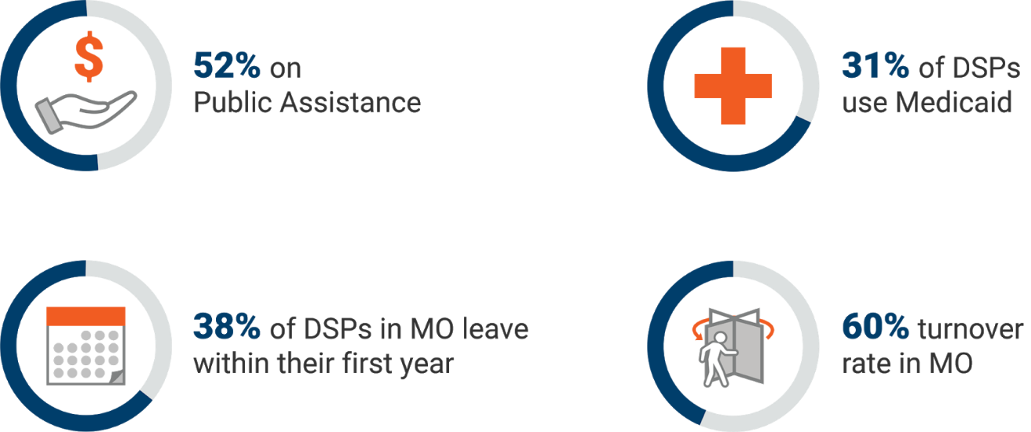

Industry Overview
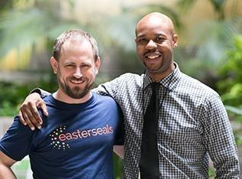
The role of the Direct Support Professionals in the lives of people with disabilities is key to independence and self-determination. These fantastic people help eliminate isolation from the community at large.
Today, individuals with disabilities are active, full members of our community. They hold jobs, volunteer, develop hobbies and skills, form friendships, and enjoy the freedoms and responsibilities that are their right. They can pursue careers of their choosing and set personal goals. The difference in their lives and the lives of their loved ones is tremendous. Direct Support Professionals and the organizations that employ them make this system possible.
The work is challenging but also deeply rewarding. When first hired, Direct Support Professionals go through as much as 55 hours of annual training depending on their role, and an additional 18 hours each year for continuing education. Some stay with one individual for most or even all of their career. They invest themselves in the success of the person they support, often coming to feel like family.
Currently, 20,000 Missourians with intellectual and developmental disabilities live with a caregiver over the age of 60. This will create a significant issue for the state if rates are not increased - as there will be no providers available to these individuals entering services. The state will feel the economic consequences as people enter nursing homes instead of living independently and contributing to our society as a whole.

Today, the pressure of stagnant, low wages are forcing many of these committed professionals out of their careers and away from the people they support. To be very clear, these industry issues are not fueled by a lack of job satisfaction, internal reward, or a sense of purpose. Qualified, compassionate employees are leaving these jobs because they can’t afford to pay their bills and still do what they love
“As a Direct Support Professional, I work seven days a week. I have Thursday morning off but work Thursday evening, I have Friday morning off but then work a 16-hour shift from Friday until Saturday at 3:00 PM. I never have a full day off. I love my work and the people I get to support, but I have to work overtime just to make ends meet - I’m often exhausted.” - Direct Support Professional, St. Louis

Economic Impact
A report recently published by the President’s Committee for People with Intellectual Disabilities, entitled “America’s Direct Support Professionals Workforce Crisis: Effects on People with Intellectual Disabilities, Families, Communities and the U.S. Economy” states, “The direct support workforce and the service system that supports it are in a crisis that will result in catastrophic outcomes for people with intellectual disabilities and their families unless significant and immediate responses are implemented.”
The report continues, “Nationally, the average annual turnover for positions is an estimated45 percent, with a range of 18–76 percent. About 35 percent of Direct Support Professionals leave their positions in less than six months, and approximately 22 percent leave within 6–12 months.” As a point of comparison, across all industries, as reported by the Bureau of Labor Statistics, the national average separation (turnover) rate is 3.5 percent.”
“The magnitude of this workforce issue is hardly seen in any other industry, making running an efficient and effective direct support based business nearly impossible. The costs of replacing a Direct Support Professionals in the Intellectual Disability and Developmental Disability services industry has been reported to cost between $2,413 and $5,200. The aggregated cost is substantial. Nationally, these costs are estimated at $2,338,716,600.”

Consequences
This past year we saw the consequences of this crisis intensify as providers from across Missouri began discharging individuals from services due to extraordinarily low rates (rates are not uniform for all clients – a complicating factor to this crisis). Also, it is important to point out that organizations are not accepting new referrals to services because they cannot hire enough staff without an immediate rate correction. We fear many more will lose services due to the significant turnover found within the industry. This will ultimately force people, young and old alike, into nursing homes or back to living with aging parents who cannot provide adequate care.
At Easterseals our turnover rate was nearly 45% last quarter. With the Senate's help, a rate correction would impact the crisis by reducing staff turnover, bolstering our ability to hire competitively and toward supporting more Missourians.

Show-Me Solutions

Disability service providers are not alone in this crisis. With an aging population of baby boomers and better treatment for chronic illnesses, we’ve seen a labor boom in the health care sector. It is projected that the United States will need an additional 2.3 million Direct Support Professionals in the next five years. Meanwhile, services are currently underfunded in Missouri by an estimated 40%.
Considerable investment in this crisis is needed to strengthen the employment of Direct Support Professionals - an investment that creates an essential, sustainable framework for the system that provides support services for people with disabilities.


Taking Action
While the situation is dire, there is a clear path forward. For the first time in years, we have support from leadership in Governor Mike Parson. The Department of Mental Health (DMH) requested a $76.5 million increase in state revenue funds to correct the significantly underfunded reimbursement rates. From that recommendation, Governor Parson agreed to include $12.6 million of the request.
This is a substantial step forward.
With the help of the Department of Developmental Disabilities and many state representatives throughout this year’s budget process, the Missouri House of Representatives provided an additional $7.5 million. That means that today, a total of $20.1 million in funding is proposed to deal with this crisis.
However, disability providers still need $56.4 million to even begin to correct this issue and an annual 3% Cost of Living Adjustment (COLA) to fix this broken system moving forward.
Now we look towards the leadership of the Senate to continue this forward momentum.
“My son trusts staff to help with the most invasive and private aspects of his life, literally helping him to shower or use the bathroom. Who puts him to bed and is there when he wakes up? It is so critical that these are people who he knows and with whom he can develop trust. Rotating strangers who have little incentive to be involved or care about his future who have minimal investment in him would be my worst fear.” Parent, Community Living Program

What You Can Do
The time to act is now. As the Senate Appropriations Committee considers the House Budget, the need for your action is immediate. Call or email your Missouri Senator and tell them why people with intellectual and developmental disabilities are a priority.
Tell them that allocating $76.5 million to rate reimbursement with an annual COLA is the only way to ensure more than 100,000 Missourians with disabilities have quality supports and that this investment will help save taxpayer dollars by making sure Direct Support Professionals turnover rates are reduced.
Your action, and your Senator’s vote and influence, will make sure programs and supports continue. Missouri cannot afford to Band-Aid or ignore this issue.
Please join me in calling your Missouri State Senator today.

